

PRAYAS

*Experiencing the humane*

**SUBMITED TO**​ : DR DURGANSH SIR

**SUBMITTED BY :**​ THE SOULED

**GROUP MEMBERS**​ :

ARUSHI SHAH 11

VATASLYA TEGWAL 78

SURMAI ADHIKARI 80

*REMEMBERING AGILE MANIFESTO:*

* 1. **Individuals and interactions over processes and tools**
  2. **Working software over comprehensive documentation**
  3. **Customer collaboration over contract negotiation**
  4. **Responding to change over following a plan.**

**ABSTRACT**

The objective of this report is undergo deep into the agile based project and to prepare a proper documentation before deep digging into the user interface.

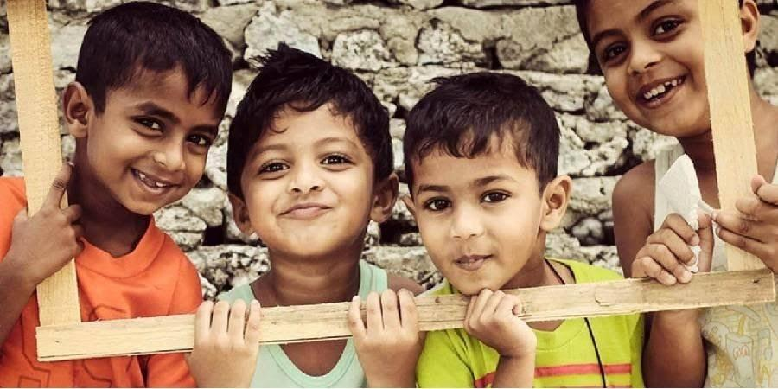

# INTRODUCTION​

As seen there are many platforms available already in the market for eg. Amazon.com is a vast Internet-based enterprise that sells books, music, movies, house wares, electronics, toys, and many other goods, either directly or as the middleman between other retailers and Amazon’s million customers. Its web services business includes renting data storage and computing resources, so-called “cloud computing,” over the Internet. Or we can see **Facebook**, American company offering online social networking services.​

Facebook was founded in 2004 by Mark Zuckerberg, Eduardo Saverin, Dustin

Moskovitz, and Chris Hughes, all of whom were students at Harvard University.

Facebook became the largest social network in the world. And many more,​ such we want to introduce the system *PRAYAS* which is an open platform where we are eligible to donate our secondary or unused things to needy peoples with our choice of NGO’s. With a secured network and certified database of different NGO’s. Basically, PRAYAS is developing an open source system which comes under the agenda of helping and showing concerned with the humanities. PRAYAS is developing a system which is child centered and compassionate that revolves around civilized concern. An open platform where million or billion of users can help the needy ones on just a click away with a secured network ID where all other networks lack due to the interface they provide. *Prayas*​ can be a widely connected networking platform due to the connections it will form with **NGO's**​ and ​**OLD AGE HOMES**​. ​ In addition to​ theories of unemployment, the effects of unemployment within the economic system. *Prayas*​ provides employment too! The delivery executives or the employees which will act as a carrier in processing the donations to the desired locations and also sending the acknowledgments to the users who have provided the donations. Also, with secured network, *Prayas*​ will provide the payment gateways to the people with easy transactions. People will be able to donate money as well as to the NGO’S. With high-tech full security like any other money transaction apps PRAYAS will be a lot more than that it offers. It will be a non-selfish fund-raising software and will allow the users to check the growth of PRAYAS on day to day basis by checking the statistics. A statistic will be monitored daily and maintained according to the transactions which will be happening every now and then. It will also help in determining the progress made so far. And due to this very transparency people will be more interested to give their inputs by relying on this initiative that provides with an open platform to billion people to help in a friendly manner.

**AIM**

To develop an open system for social awareness.

## OBJECTIVES

* Give resources to the child who are not able to buy for themselves.
* Provide shelters.
* Reduce Unemployment.
* To provide the interface between the donor and the receiver.
* Open platform donation website.
* Helping people on a larger platform.
* Creating an Interactive user-friendly environment.
* Rehabilitation measures in the social problem issues like delinquency, child pornography.
* Social and economic development
* Reduce child labours
* Transparency over a network
* Security to the users

## SCOPE

* Organize events on behalf of “PRAYAS”.
* Increase the effectiveness.
* Can be converted into an app for users who wants to access it on their smart phones.
* Further unit distribution of system can give rise to many other small projects.
* Implement it as website for ease of access to end user and the user who doesn’t have smart phones.
* The main thing that we provide is to give platform to thousand of NGO‟S and Old age homes, so that people can easily get information about them.

*SOFTWARE REQUIREMENT SPECIFICATION*

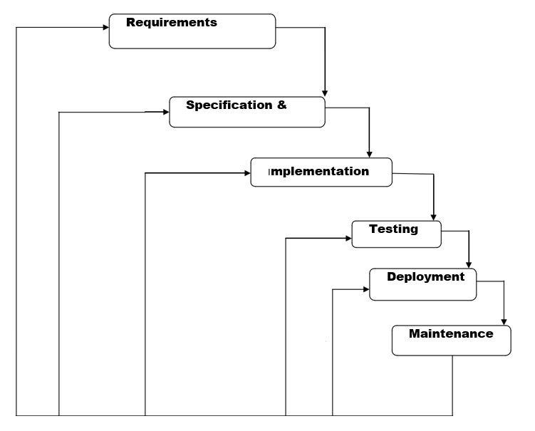

**METHODLOGY**

# WATER FALL MODEL

*REQUIRMENTS:*

* Database of different NGO’s - we will be collecting information of different Ngo”s near by the user ., eg.owner,associative head.also our website will map the Google database with user so it becomes easy for the user to choose the place where they want to donate.
* Open working platform - open platform will be build by the software so the website becomes user friendly. Such that multiple users can access through it .{AM.1}
* Security : As the website contains different users so each user will be having unique identification such that they can safely login and donate the things. The user passward and login can be changed on the user prefrences .
* Users - Users are required to make the website working as they will be the main entity in the project to contribute towards donations.{AG:3}
* Donor and Donations - website will accept different forms donations for eg. Books,cloths,blankets,stationary,cash.
* Delivery Executives/employees – To transfer the Donations from one place to another.hence which increase the employment.

*SYSTEM DESIGN:*

A working website will be made by using the output of the requirements. Where user can securely login into their account by the unique id and password and once this is done, a map will pop up with the information of different NGO’s in there surrounding or in their respective diameter. Prayas contains easy money transactions similar to other online payments sites along with the tight security, that it provides. At each cash donations or the other donations **(**​ **old age help)** users will be​getting the bonus points for their continuous inputs which can be further converted in the form of a bank cash and will thus, lead to the more involvements.

Also, there will be 4 icons which will pop up there symbolizing.

Donate

Old books, stationary, cloths, blankets, cash. On each good donations user will get coupons and coin for which converted to their bank account.

Contribute

Contribute to the NGO’s as a volunteer for the different activities which takes place in, contributer will be assigned according to their social skills and get a approval from the NGO’s.

Teachers to needy

The students who are in universities and willing to share skills to the poor children’s who didn’t get a chance to acknowledge the good education. They can contribute to their nearest NGO and teach the children’s and can utilize their summer vacations by nominating themselves. They can nominate themselves on website. And can pull request which should be sent to the NGO’s.

Match with Old Age

​*Prayas*​ allows to connect with the old citizens with peoples who have never seen the care and concern of the guardians in their life. It’s an initiative to match the old age people to the children with whom they are most compatible with. There will be daily database of people who wants to interact to the kids and the people who are making contact with them. They can check the timing slots by pulling a request on the website and they will be updated with the time and date which gets generated by checking all the necessary conditions. Through all this security measures one can easily visit the NGO’s as it helps both the parties to feel less lonely along with their safety which will also be a major concern here. Users will have the access to take 2 people under them, one being an old citizen and the other child so that user can have the access to arrange meet ups and provide online donations to both the parties at the same level.

*IMPLEMENTATION –*

With inputs from the system design, the system is first developed in small programs called units, which are integrated in the next phase. Each unit is developed and tested for its functionality, which is referred to as Unit Testing. The first unit will be the complete database which will be getting from different websites,users,employess,contributers.Once all the database will get prepared we will make the website functional using the database of different entity and also matching them with their attributes. Using HTML/CSS/PHP. We will be using c++ to make the payment gateways functional. Once the data and icons get established in the website, we will make it functional using CSS.

There will be different panels for both the users and employee updates.so that millions of people can process over a single tool to interact with different

NGO’s and people who are already keep working for the good cause. {AM :1}

*INTEGRATION AND TESTING -*

All the units developed in the implementation phase are integrated into a system after testing of each unit. Post integration the entire system is tested for any faults and failures. if any failure occurs, we will go back to the previous stage to check what is gone wrong. checking errors will be perfect to make the project work.

### *DEPLOYMENT OF THE SYSYTEM*​ –

Once the functional and non-functional testing is done; the product is deployed in the customer environment or released into the market.

### *MAINTANENCE –*

There are some issues which come up in the client environment. To fix those issues, patches are released. Also to enhance the website some better versions are released. Maintenance is done to deliver these changes in the customer environment. PRAYAS will be able to fix the bugs which will occur with website such that it understands the user point of view and try to make it more flexible and reliable to the users where they can easily understand the website and able to share what changes are required.{AM :4}

APP SCREENSHOTS

Data Flow Diagrams

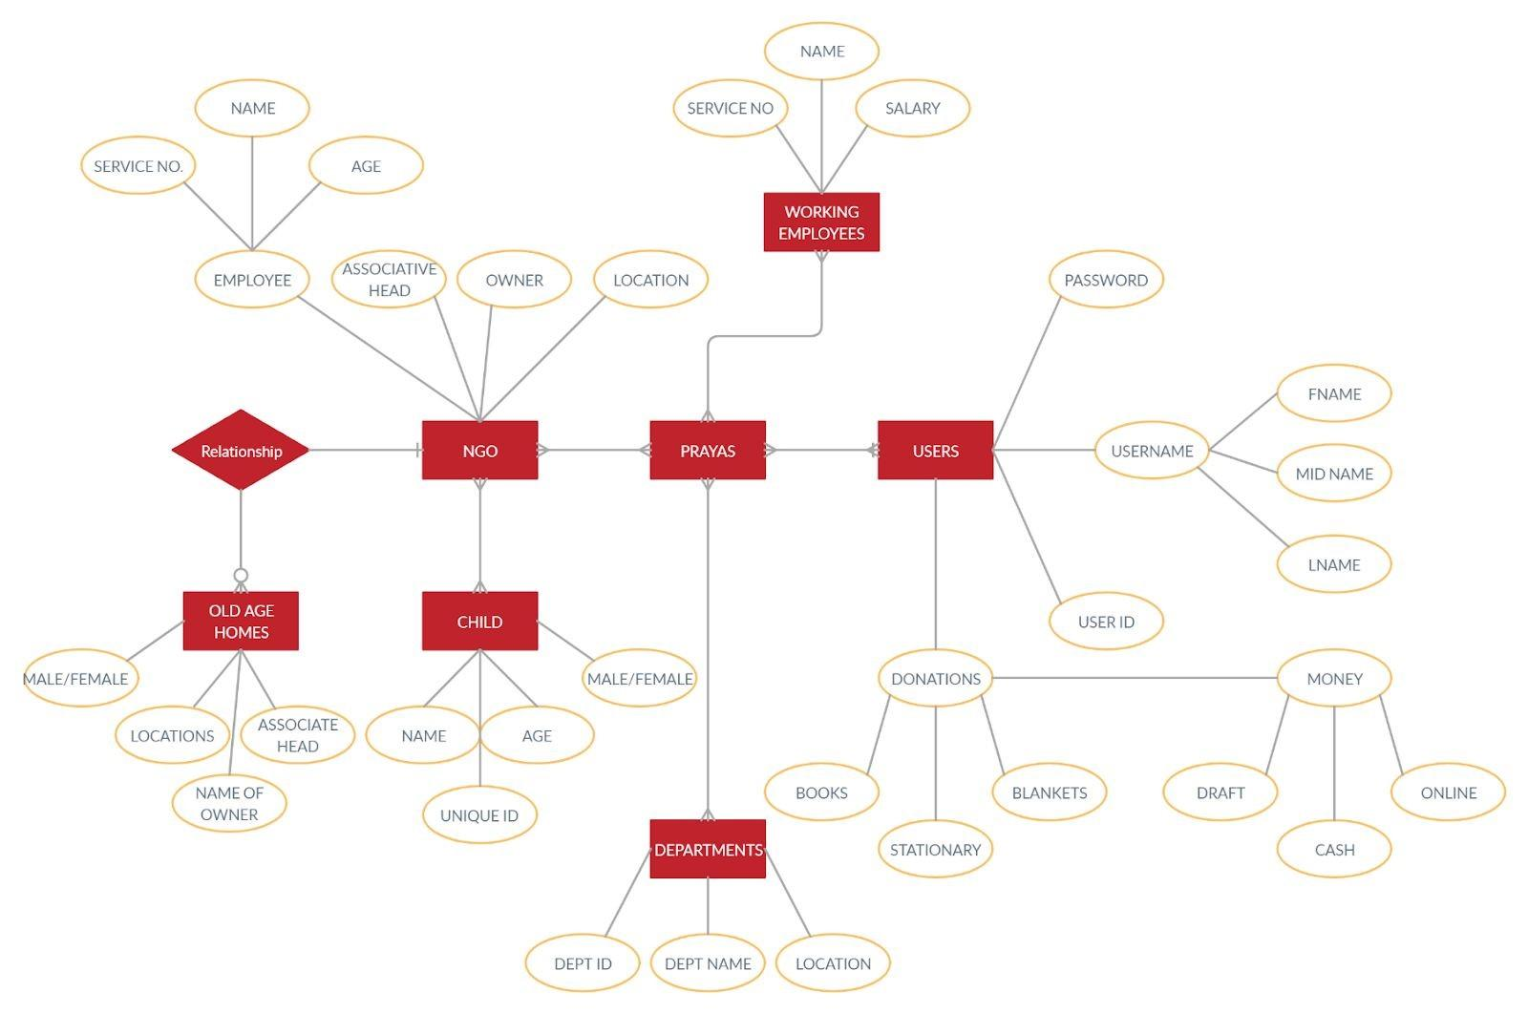



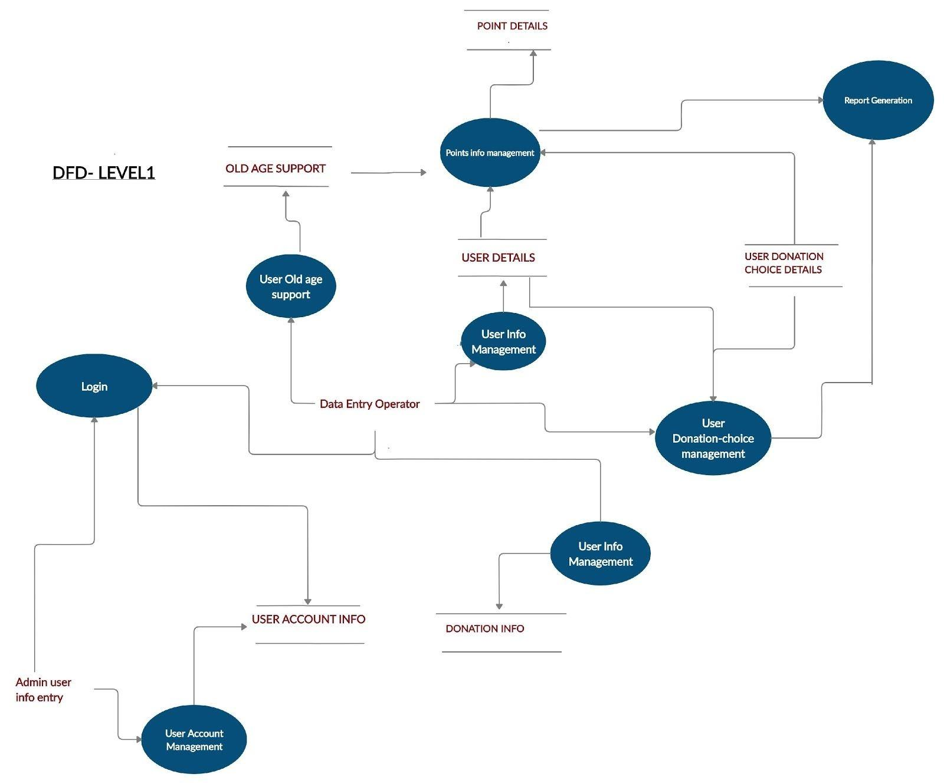

**DATA FLOW DIAGRAMS LEVEL 2 PROCESSES**

Authentication process:

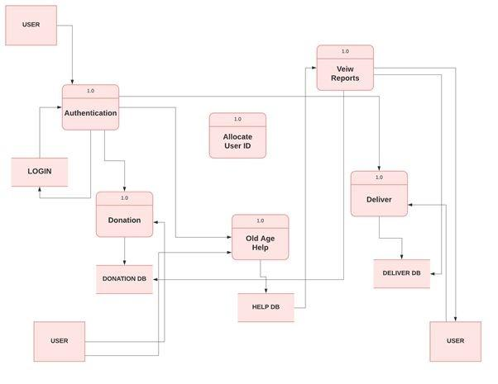

## Authentication Process

A basic responsive UI will be designed using frontend UI, Bootstrap which will provide users a platform where they can easily login into it and help in donating, delivering things (unused or left- over things) to the needy ones. The login details of each user are being managed and the user is provided with a unique personal ID which is linked to their day-to-day activities. With each transaction being made for the donation or involvement in activities of delivering the content and help for the old age homes folks, users are allotted with the unique ID every single time.

This will in turn help in providing users with high-tech security.

Steps for authentication process:

1)​ User is provided with a software platform, UI form where he can easily login into and provide the necessary details required by the platform.

2)​ The details of the user which he enters gets authenticated.​

3)​ Once, this is done he is being provided with the unique ID for his​ using the various benefits provided by the interface.

4)​ There are three main choosing options in the site, which users can​ see after logging.; ‘Donation, Old-age help and Delivery’.

5)​ A report is being maintained about user’s details.; his usage, the​ number of times he visits the site, etc.

**\*\*Methodology being used**:​ A form is made that asks the login details from the user using php. While a UI using bootstrap is created for the same.

**Points Generation**

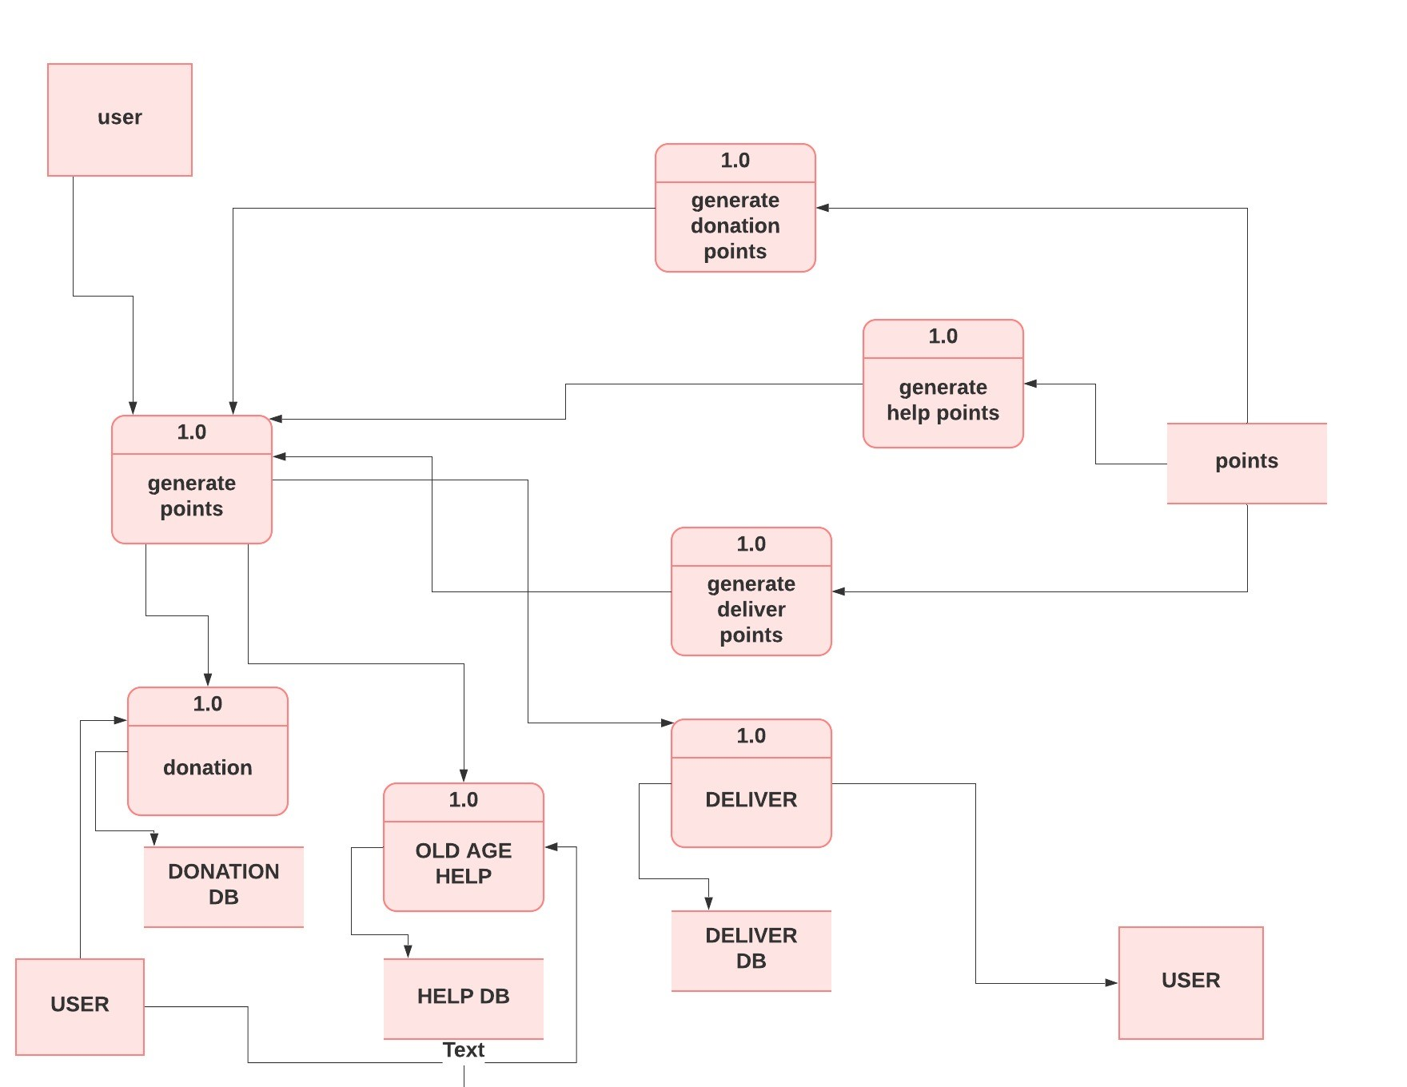

### Points Info management

With the growing involvement of the user in helping the people, their weekly basis KPI’s (Key Performance Indicator) are maintained. They are then rewarded points on the basis of their daily inputs which they make. A database comprising the user's activity is recorded which helps in maintaining the status of the user and evaluation of the user’s activity.

Steps for points info management:

1. On a daily basis, a KPI is maintained for each user with his different ID’s every time, his usage, the number of times he did participate in donation, help and delivery processes. All these data are stored and are linked with the help of SQl programming language.
2. All the data is organized in a systematic way in a table which is further joined all together by the using the Key’s concept in SQl.
3. The common data is being joined using the JOIN concept in DBMS.
4. And finally, there is the final table consisting of point details, user name, ID along with all other joined data.
5. With data being updated, users are able to see their points through their reference ID.

**\*\*Methodology being used:** ​ A bunch of databases using SQl will be​ created which will comprise of user’s activity, user’s ID, their KPI details and many more with the help of primary key and foreign key concept and then merging the same into a single table using the concept of JOIN in SQl programming language.

## Report generation:​

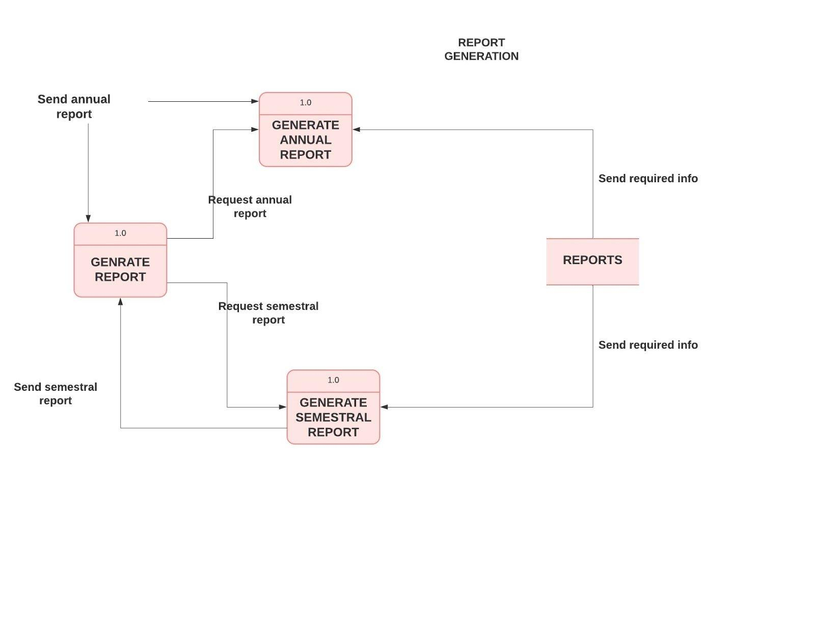

Report Generation

With a lot of databases, a report is being maintained for clear understanding of the multiple processes which are linked to each other. The report is however, generated both annually and semesterly. A database is maintained for the activities which further helps in many other processes.

Steps for report generation:

1)​ All the activities are evaluated in the same manner by using the​ database consisting of user’s info, his donations, the points which he gets.

2)​ The data is firstly organized in a systematic way in a table which is​ further joined all together by the using the Key’s concept in SQl.

3)​ The common data is being joined using the JOIN concept in DBMS.​

4)​ And finally, there is the final table consisting of point details, user​ name, ID along with all other joined data.

5)​ With data being updated, a daily basis report is uploaded.​

**\*\*Methodology being used:** A bunch of databases using SQl will be​ created which will comprise of user’s activity, user’s ID, their KPI details and many more with the help of primary key and foreign key concept and then merging the same into a single table using the concept of JOIN in SQl programming language.

PROCESS DONATION -

ALGORITHM-

The online open platform prayas will provide options to the user i.e donations options.

Donation options -

* 1.staionary
* 2.books
* 3.blankets (daily essentials )
* 4.cloths(new,old,usable)
* 5.SECURE DONATION - under secure donation money donation will be done under secure network as security of OTP and secure USER ID.

1. Users will choose from donations which donation he/she wants to make. Once the donation is chosen .PRAYAS will let users see all the databases of different NGOs which are around their diameter . users can choose by their preference which NGO they will donate into.

1. After step 1 and step 2, A delivery will get scheduled by prayas. At the instance the user taps the donate button . pickup and delivery will get scheduled. User will get the acknowledgement from the delivery service .on their respective mobile phone from which they have login before

1. After step 1,2,3. A receipt of acknowledgement will be sent to both the parties donor and receiver .

1. Taking donations from one place to another will be the work of employees.i.e delivery executives . once the donation takes place will move to step 6.

1. Once the user receives the donation an acknowledgement msg will be sent to the donor that their parcel is being received by “receiver’s name “. Thus PRAYAS provides transparency to donor and receiver.

1. After step 6 . donar will earn coins through prayas, which will later change into money and can be submitted to their respective bank account

SECURE DONATIONS

1. Step 1 and 2 will be the same .

1. Prayas will show different option from which users can donate money :

1.online

2.cash

3.draft

1. The money transaction will be done on the secured network by PRAYAS with the data of user i.e name ,contact,attached account,gmail. Users can choose the payment amount and can easily donate money through easy payment options .

1. After step 3 . users will get acknowledgement that Respective NGOs have got the cash donation from users.

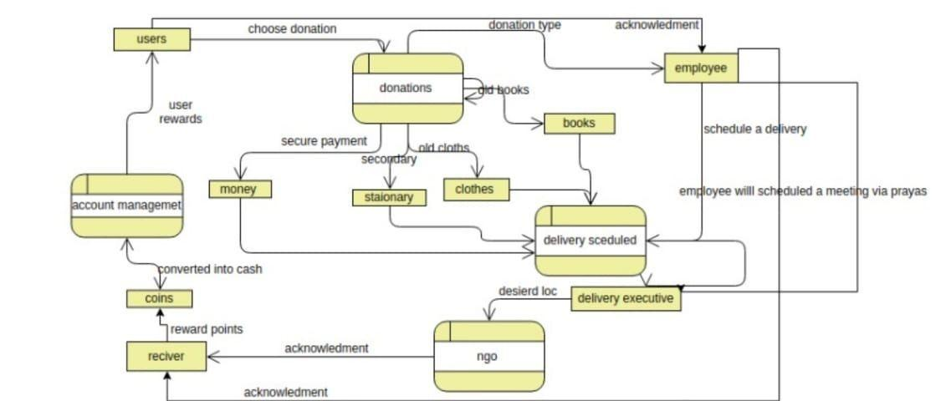

PROCESS MAPPING (NGO MAPPED WITH OLD AGE HOMES) ALGORITHM -

1. There will be two seperate data one for different NGOs. and another will be old age homes . from step 2 there will be various steps to map the old age home with orphange childrens

1. The orphanage data and the old age home data will be merged according to nearest locations .eg. if an orphanage is close to or in a diameter of any old age home then the data will be merged together.
2. prayas allows only validated facilities to register and provides contact details and map locations for assistance
3. After step 1,2,3 Prayas allows old-age homes and orphanages to sign up and organise meetings, thus facilitating children and senior citizens to spend time together.

1. Seminars,activities will be planned and launched on the website itself.
2. The meeting can be fixed between the two parties according to the merged data

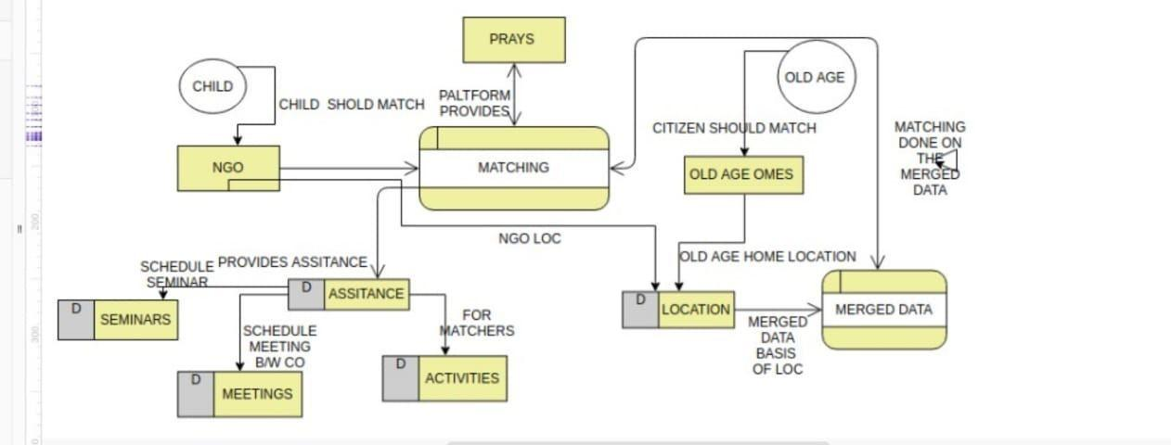

PROCESS DATABASE

How prays will get the data of different ngos

ALGORITHM

1. Determine the purpose of your database -Database is required so the other processes access it and give the desired results to the users and whoever accessing the website .
2. Find and organize the information required.- search on the web,and other social media handles to acquire the data as well as different ngo own websites.which will be helpful for collecting the ofowners,childrens.

1. Divide the information into tables. - after step 3 the database will be converted into different tables such as seperate tables for users,employees,children.
2. Turn information items into columns - add the consecutive information in the different tables which will give rise to the actual data which can be manipulated accordingly using sql commands.
3. Specify primary keys - identifying the separate unique keys for each table so that identifying the data will become easy and handy.by specifying the primary key we can make relationships with different tables which contain the different data which should be manipulated or should be used on the desired conditions. For eg. The primary key in an employee will be service no., for users the primary key will be a unique id from which they will login into prayas. And for children the PK will be ngo’s unique ID of a child.
4. Set up the table relationships - There will be 3 main tables: employee,users,ngo,old age home. And all other tables will be referencing from these tables by foriengn key which will be taking reference from the primary keys.
5. Refine your design the different tables and database which is input of these tables will be refined. the unnecessary data will get deleted to decrease the complexity of the data . thus unwanted data which is not required for the purpose shall be deleted to work effectively.
6. Apply the normalization rules- After step 1,2,3,4,5,6,7 . now the data will get rady and mutable. We can apply different normalization forms like 1N,2N,3N in order to reduce data redundancy and improve data integrity.Redundancy in relation may cause insertion, deletion and updation anomalies.

So, it helps to minimize the redundancy in relations.

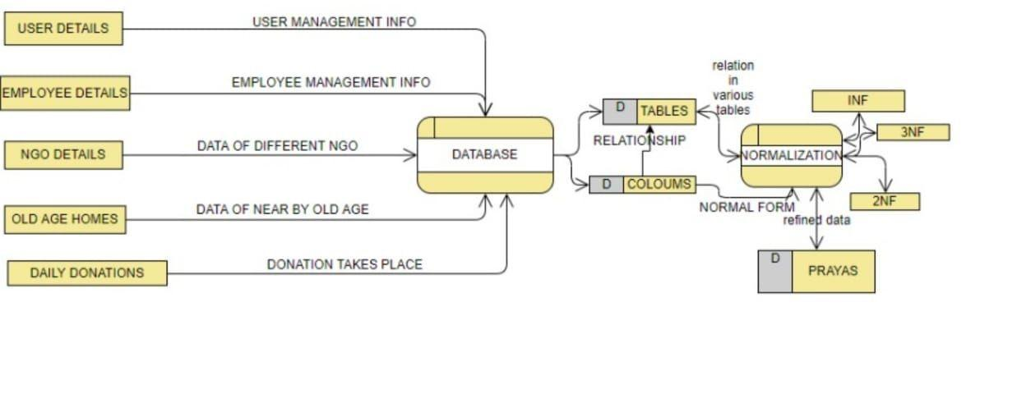

Web Integrity

Integration with the resources such as Internet would be very crucial for this process as it not only ease the user to enroll, record and grab the information of him/herself but also enables the employees behind the project to manage and handle the data that is gets available to them online and as well as offline. With the help of languages like PHP, HTML and databases like MYSQL the ease of handling the data becomes more efficient. There are sub processes comprehends with Internet Intergrity which are as follows:

Office Automated System

There are multiple online document management apps like Google Sheets and Google documents which automates the task that collects, process, store and transmit data and other form of communication among individual, group and organization. Example includes word processing, electronic mail, desktop publishing and image processing.

Expert Information System

It is programmed through various languages such as Python, Django etc. which reads human behavior by which they create more data which gets stored in the databases and creates a newer type of information with the help of Artificial Intelligence and creates unique options for the users to get more benefit.

Signup/Login

Before using any kind of services that are provided and will be provided the user needs to signup and the employees which are working for the welfare needs to login which is only available through internet integration with the software.

Algorithm:

1. User will login through the credentials.
2. Checking of the status of his/her donations.
3. Rewards generation counting through database.
4. Offline to Online report generation
5. Donor gets facilities of becoming donor/helper/tutor etc.
6. Payment gateways build for the donation through lime or freshpay.
7. Secured OTP generation through bank.
8. Connection with banks to provide 126-bit security.
9. Cloud server to optimize and manage data of the user.
10. User can access database that is visible to them easily and effortlessly.
11. Customer support with the internet integration
12. Web services easily available through .com domains.

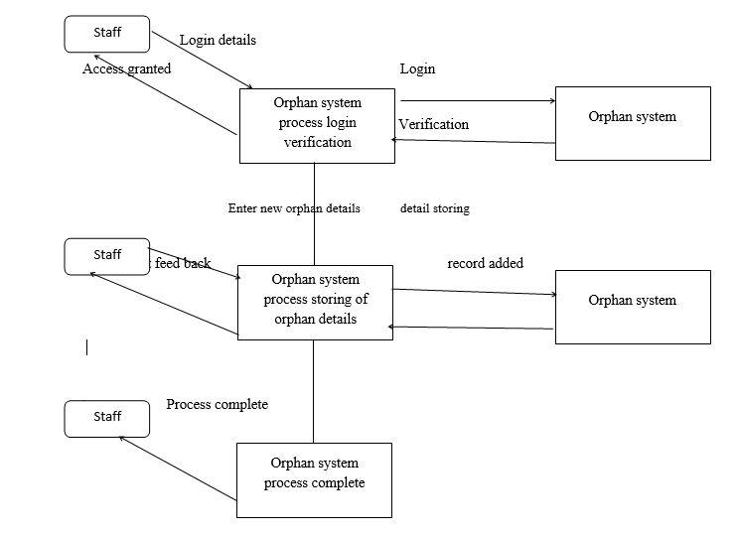

Fundraising

Without any kind of fundraising or donor the project for the welfare of the society can’t be spread to people who are in need and also to the people those who wants to donate. Fundraising can be achieved by the people those who seek for the welfare of the society. With the help of government services and gathering voluntary financial contributions by allowing individuals, groups, businesses, charitable foundations etc. There are multiple sub processes which can be implemented to achieve a better scope of fundraising.

Individual Donor

Donors can be parents, friends, private foundations, small corporations etc. which can provide small contributions In order to help other services to become more easily and effortlessly available to the users and fundraising by the individuals can become more efficient as it builds trust with the independent body.

Group Donors

Non-Profitable agencies, Government Services or Corporate societies can also become a part of the platform with which the ease of platform to donate the donor will also receive reward and recognition when the initiate for a greater cause.

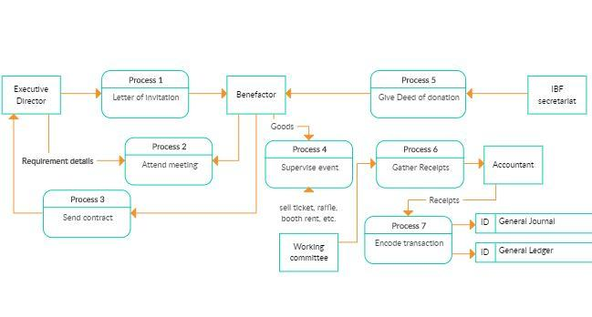

Algorithm:

1. Understanding requirements
2. Executive director schedules and gathers information
3. Letter of invitation to gather and call people.
4. Supervision of meeting by Executive director.
5. Working committee sells ticket online through digital marketing and offline marketing.
6. Gathering of data.
7. Calling customers who seeks to help.
8. Accountant generates reports of fundraisers and their donations.

Analytics

Analytics can be used by project managers to assess a project’s viability, gauge which projects are meeting Key Performance Indicators (KPI) and provide progress updates to stakeholders. Gathering and recording data for all projects is important, so a manager has the ability to see how a change made in Project A impacts Projects B, C and D. Through these insights, project managers can instantly determine whether a project or task should proceed as planned, change course or be discarded altogether.

Data can tell a project manager if a software launch is on schedule or not. Analytics can tell a project manager how each day of delay in delivering the product to consumers will impact the company’s profits. Business analysts (BAs) use advanced data modeling and data warehousing to show actual costs across possible dates of completion, based on current and alternative rates of productivity. They can also predict customer responses to various product offerings, pricing and delivery methods.

Analytics can forecast resource shortages, equipment failures, asset availability, production and maintenance costs, and any number of other competitive factors a business may face. Using analytics, project managers have the power to see how a potential task affects outcomes before they happen – and to make sound, strategic decisions based on that information.

Beyond simply gathering data from one project, analytics allow project managers to heighten their understanding of how every current or proposed project fits into the overall picture and affect each other. Whether the goal of a project is to increase quality, resolve a system problem, improve operations or prevent losses, analytics can give project managers the insight necessary to make it more successful.

1. Gathering data from customer.
2. Providing and checking login credentials of the user.
3. Checking status of the user.
4. Checking user database.
5. Managing data warehousing, resources.
6. Coming to strategic decision based on the information provided.
7. Accessing and optimizing data from Websites, Mobile application and offline registrations.
8. Creating an e-mail list, phone number list to inform about every events.
9. Reaching to payment apps to include section of donation in their apps.
10. Gathering and generating reports of donations.
11. Utilizing money in services and employee/staff as salary.

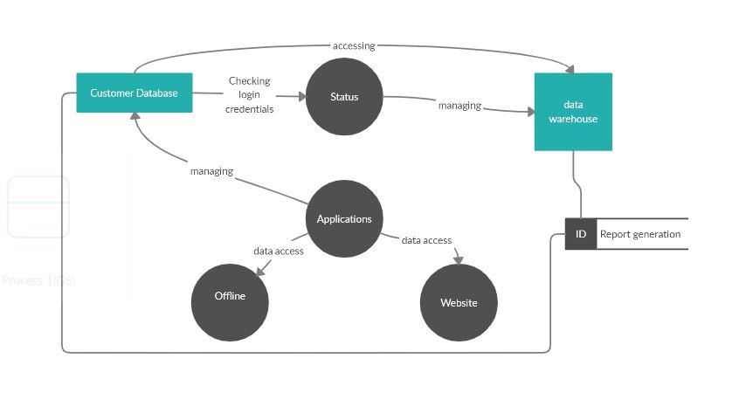

## CONCLUSIONS –

1. This open system allows users to create interactive checklists that will help them ensure a child getting all the donations which are sent by them.
2. Users can check the daily statistics on the open system
3. Users get database of all the NGO’s at one place and statistics of the data at the same place.
4. Users can donate things at one click and go thus the open system which will be user friendly.
5. Easy cash payments. With complete security check.
6. Acknowledgments will be provided to users once their donations are reached to the respective NGO’s.
7. Limiting children’s exposure to hazards and reducing children’s risk of harm.

Model to be used:

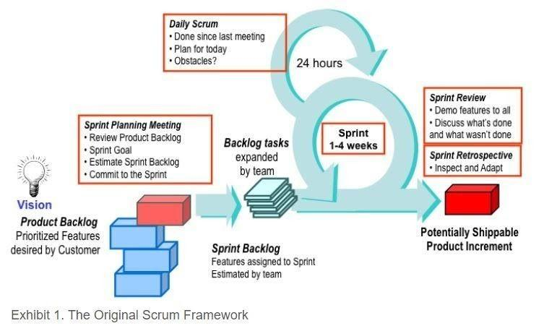

**With a major theme of “Inspect and Aspect'' Agile** Scrum methodology has played​ the most vital role in today’s project management. It has led to increased business value, projects transparency among teams, provides better quality communication among teams and has also brought fast change in the market. Due to the presence of Scrum Master, Product owner and the development team the analysis and managing of the task, Prioritizing the list by maximizing the return of investment the and the integration as well as the production of the compiled data to implement the methodology used respectively by the scrum team has lead to a conclusion of a better user experience with the help of the

Website, Mobile app. Depending on the interest of NGOs and orphanages, this project will​ be displayed in their website to be viewed by the public. This model suggests that projects progress via a series of sprints. The sprints are timeboxed to weeks. The creation of the sprint backlogs the Scrum team takes a small set of features from idea to coded and tested functionality. At the end the features are coded, tested and integrated into the evolving product or system. With the help of the daily scheduled meeting all team members attend a daily Scrum meeting including the ScrumMaster and the product owner. This meeting is timeboxed to no more than 15 minutes. During that time, team members share what they worked on the prior day, will work on that day, and identify any impediments to progress. The Scrum model sees daily scrums as a way to synchronize the work of team members as they discuss the work of the sprint. At the end of a sprint, the team conducts a sprint review during which the team demonstrates the new functionality to the PO or any other stakeholder who wishes to provide feedback that could influence the next sprint. This feedback loop within Scrum software development may result in changes to the freshly delivered functionality, but it may just as likely result in revising or adding items to the product backlog. Another activity in Scrum project management is the sprint retrospective at the end of each sprint. The whole team participates in this meeting, including the ScrumMaster and PO. The meeting is an opportunity to reflect on the sprint that has ended, and identify opportunities to improve.Scrum methodology states that each person contributes in whatever way they can​ to complete the work of each sprint.

**Fig.1. Following Sprints has led us to the discovery of a certain set of data in improving the user experience and customer satisfaction.**

|  |  |  |  |
| --- | --- | --- | --- |
| Sprints | Sprint 1 | Sprint 2 | Sprint 3 |
| Duration | 7 days | 7 days | 7 days |
| Description | Gathering Data | Data Manipulation | Report Generation |

1. Security: - Only admin, user and organization are alloted the access to the website whereas the employees are limited to use a certain set of functions. They are required to keep the data safe and secure from other users to prevent spoofing, phishing etc. Secured ways of fund transfer can be carried with a unique account number and pin number. System automatically logs out the user after a specific session of 2 minutes or 120 minutes. The website is designed in such a way to not to track cookies or leave on the customer’s computer. Back-end servers are accessible to authenticated administrators. Sensitive data is encrypted Errors that occur during any set of processes are logged whereas the malfunctioning and downtime are also logged in a separate file. Database is used to keep the log file with faster access and reduce the time complexity. The data gets saved in MySQL and can be migrated to other compatible databases.

**UML DIAGRAMS**

**Fig. A SEQUENCE DIAGRAM**

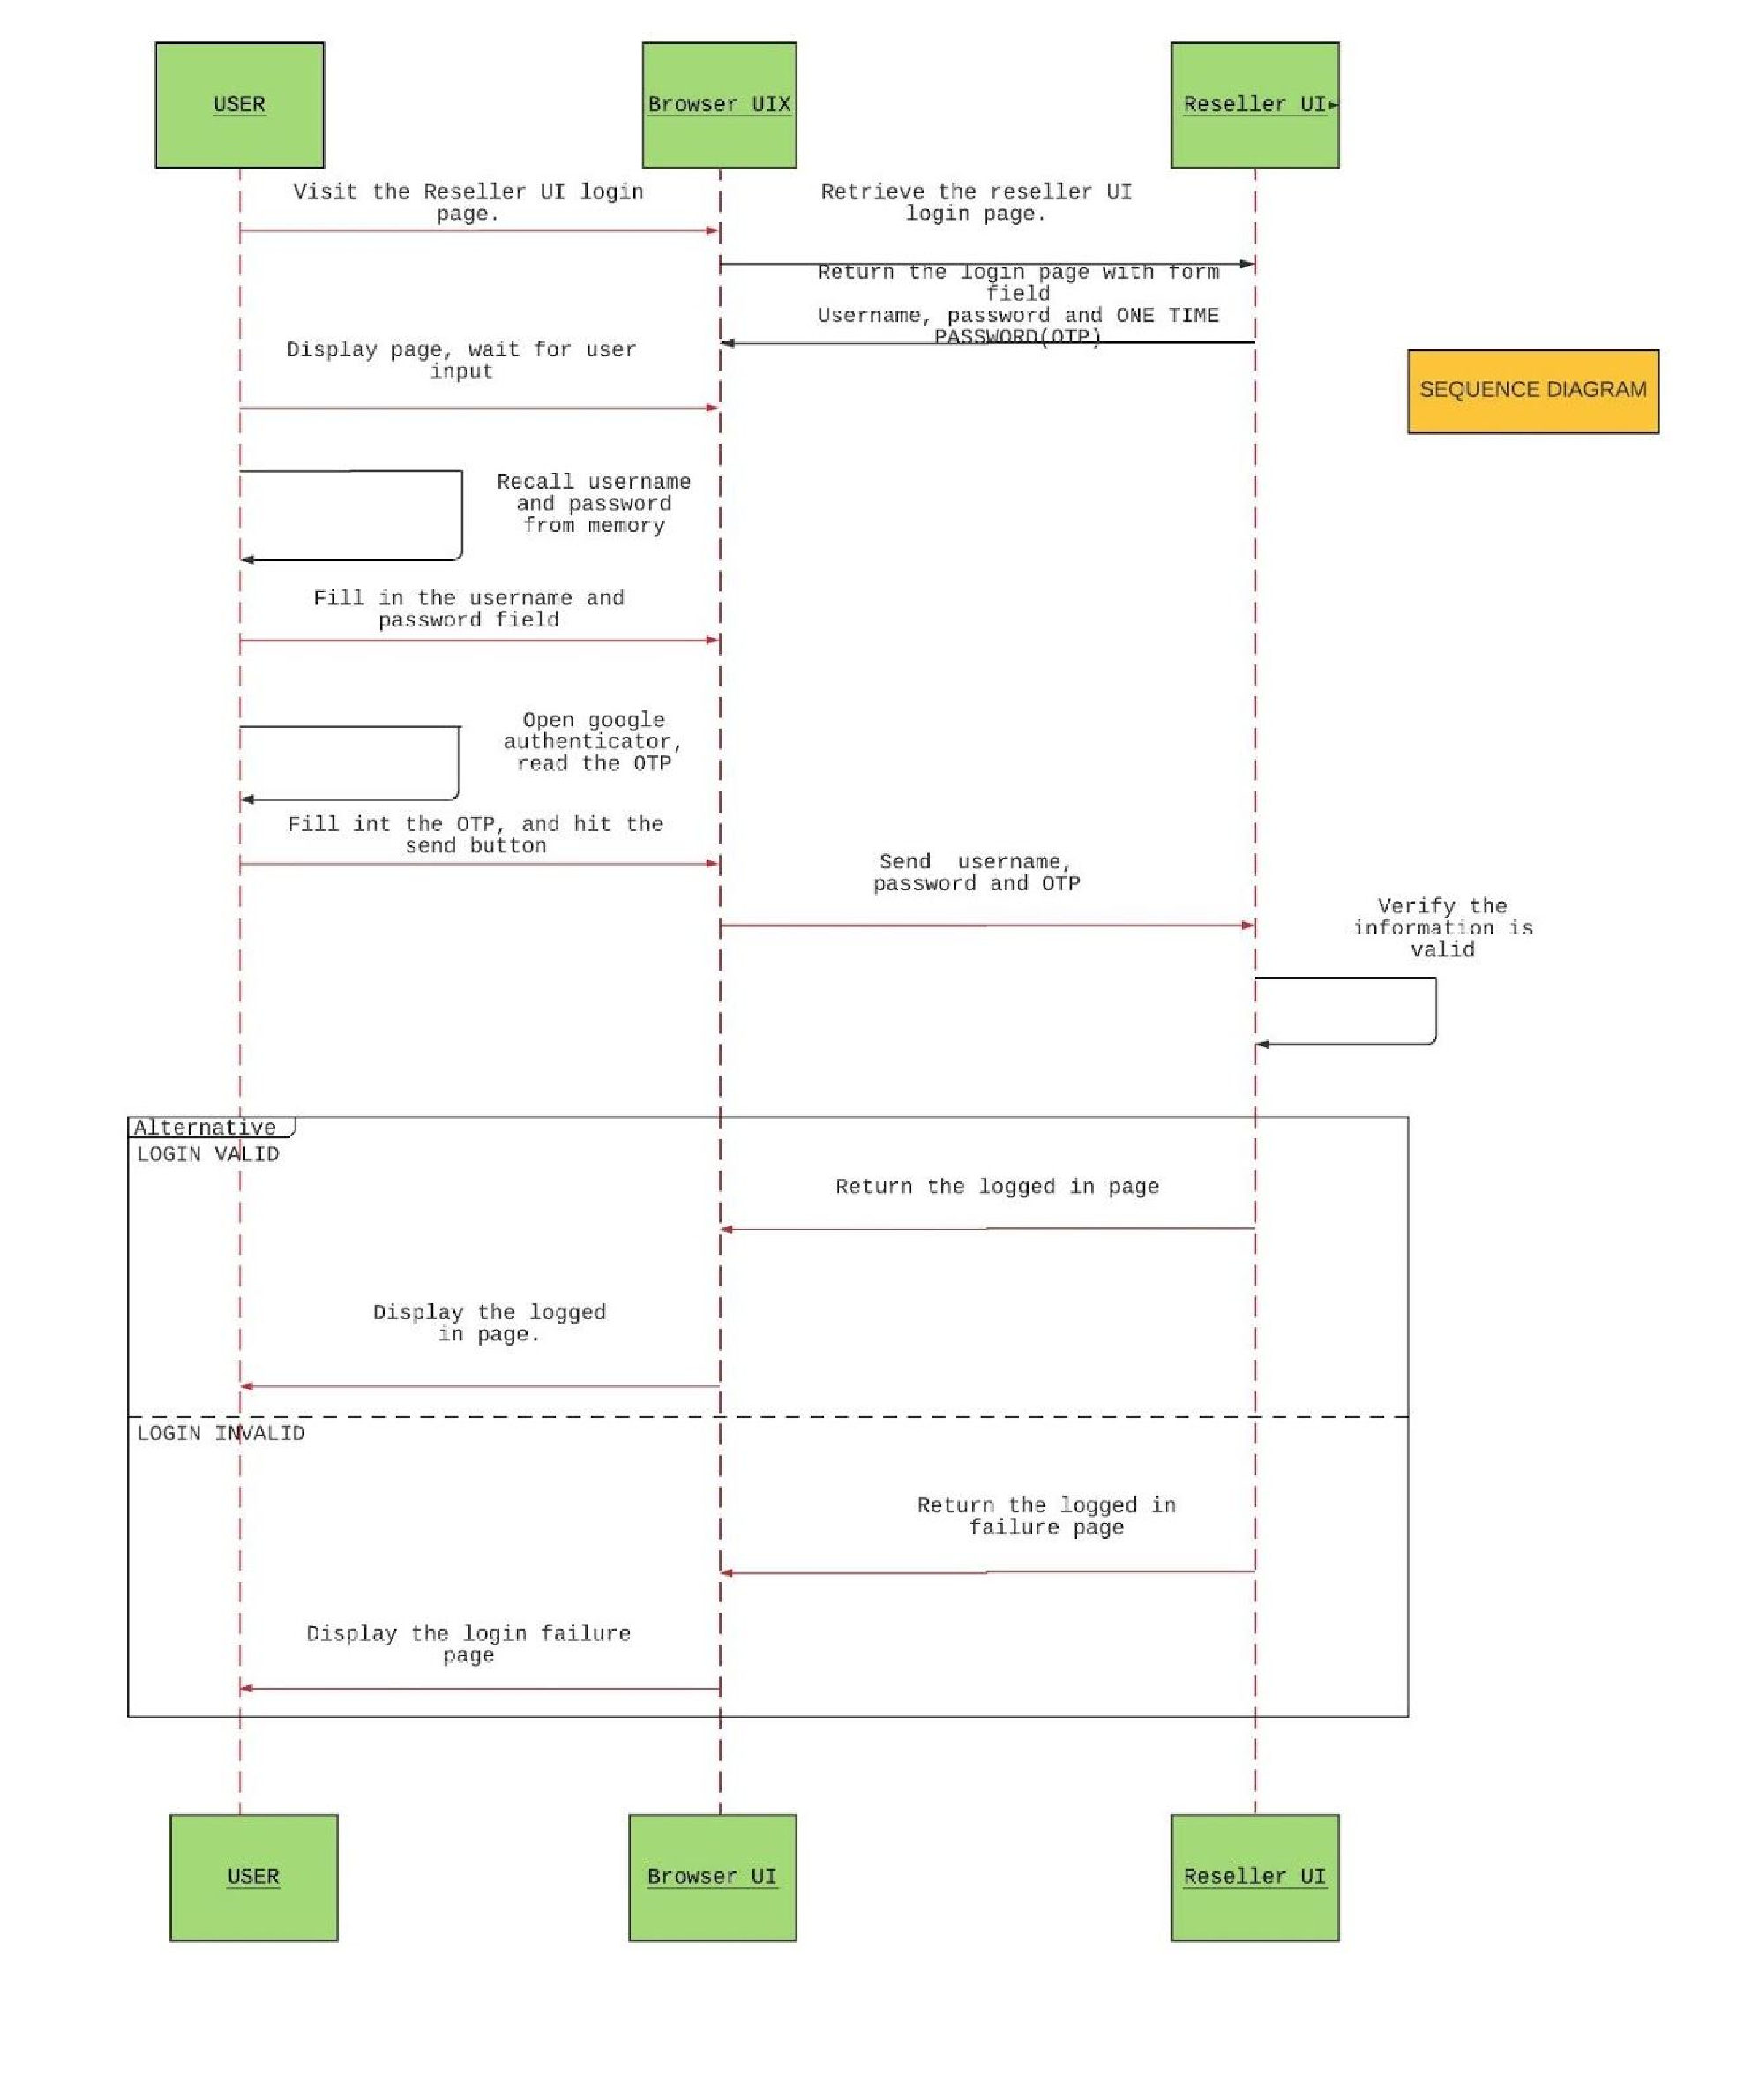

### Fig a. Sequence Diagram

A sequence diagram will help in object interactions arranged in a time sequence. The above diagram depicts the objects and classes involved in the project and the sequence of messages exchanged between the objects.

**Fig.B CLASS DIAGRAM**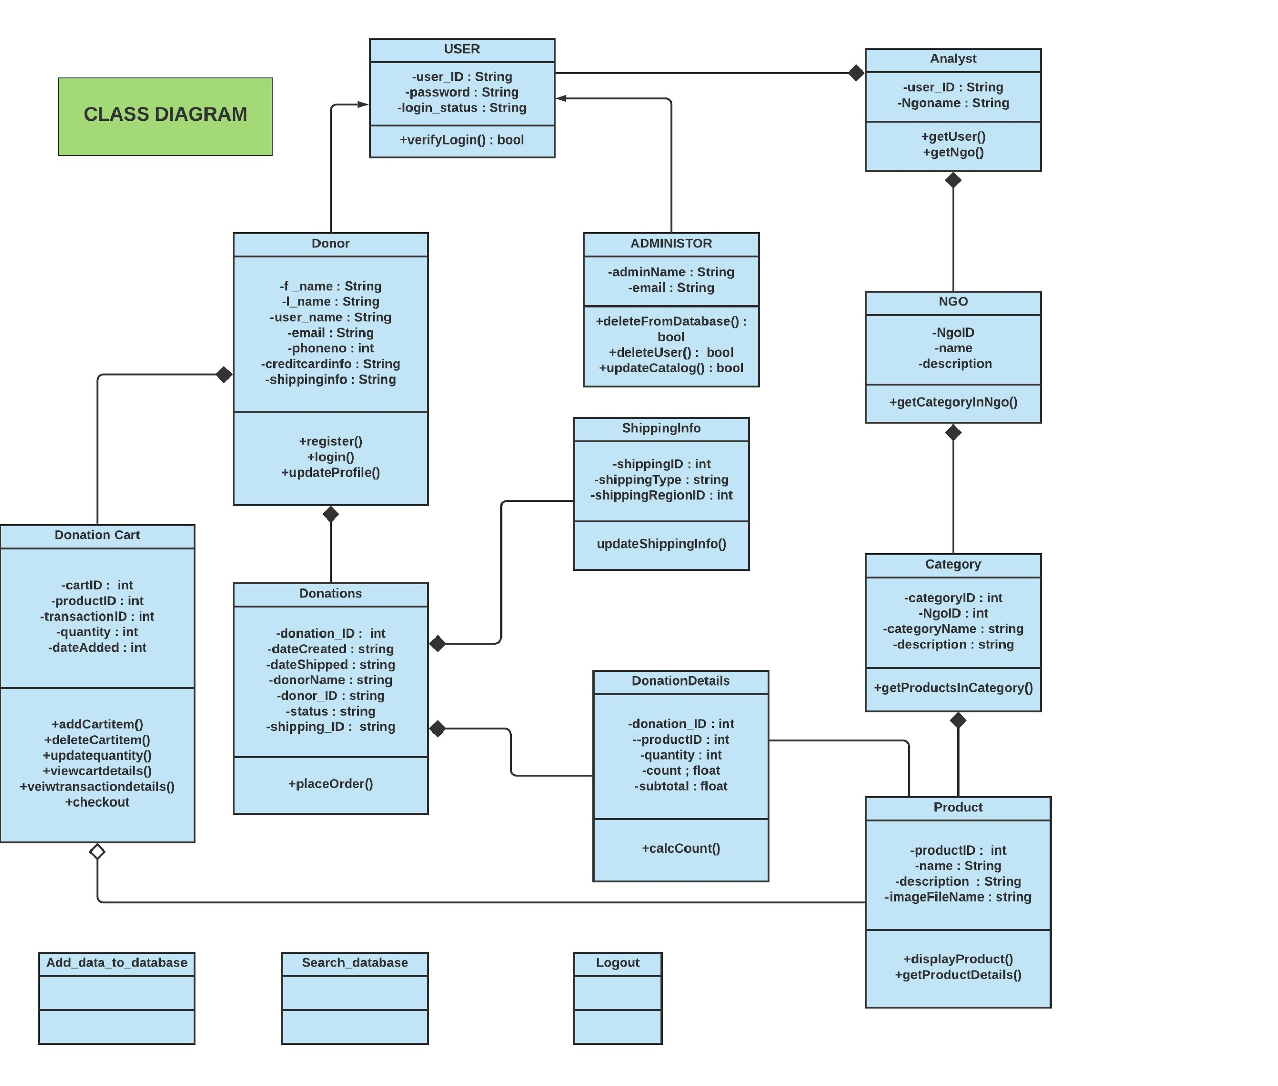

Fig b. A Class diagram is shown here defining the structure of the system by showing the system’s classes, their attributes. The relationship is shown with the help of composition and aggregation lines in the diagram.

**FIG C. STATE CHART**

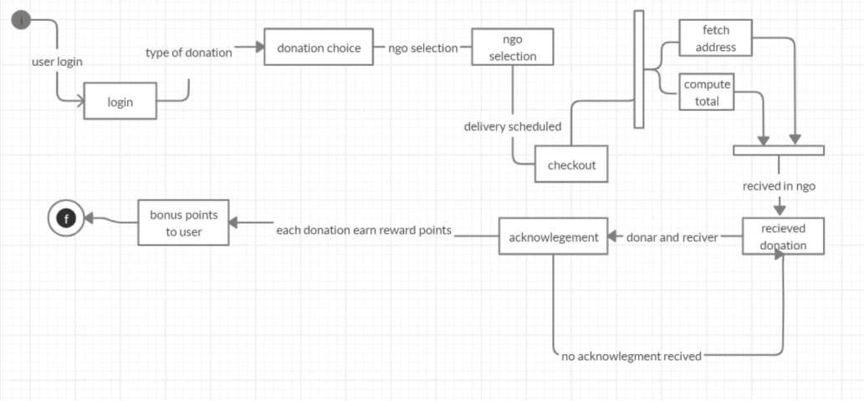

Fig c . A state chart will help in recognising the different states which take place within the project and help in understanding the user needs as well ,A statechart​ machine is an example of a finite-state machine. A statechart machine reacts to events such as signals, timeouts, or procedure calls by changing its current state.

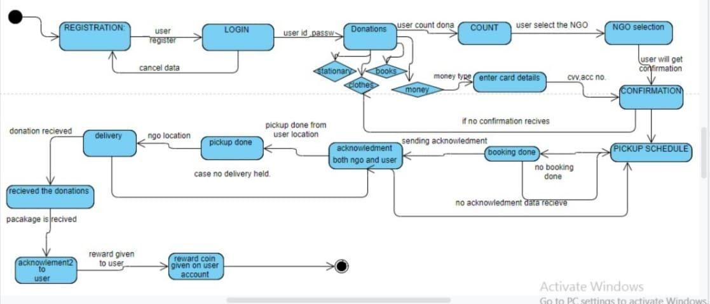

**FIG. D. STATE DIAGRAM**

Fig d. will help more in understanding the phases and each process which is associated with it. A state diagram is a type of diagram to describe the behavior of​ systems. State diagrams require that the system described is composed of a finite number of states.

### Scrum Development Team

The Scrum team is a collection of individuals that works collectively together to deliver the required product output. The development team decides the strategy to accomplish the work set forth by the Product Owner. Development teams are structured and empowered to organize and manage their work.

The scrum team drives the plan for each sprint. They discuss the timebox for each sprint, during which their work could be done. Development teams are cross-functional, with all the necessary skills required to create product increment.

### Main Artifacts of Scrum

The artifacts of the scrum framework comprises: **product backlog, sprint backlog,**​  **sprint burndown chart, scrum meeting.**

**The Product Backlog--** an ordered list of items that might be needed in the project’s final product. During the sprint meeting, everyone helps prepare the product backlog for the sprint planning meeting.

**The Sprint Backlog--** the sprint backlog is a plan with enough details that changes in​ progress can be understood easily.

**The Burndown Charts--** is a detailed illustration of the work progress. A chart is​ prepared with every task being mapped. It helps the scrum master and the team as it helps in getting updates regarding which task has been completed and which are in progress. And also, those which are yet to be started. It helps in analysing the progress of the project.

**Scrum Meetings--**  the recurring meetings that occur daily to analyse the working​ system of the whole team. They help in generating feedback from the core team members too, as through these meetings they get consistent feedback from their teammates.

**Why use Scrum?**

As per our project requirements, regular changes are required on the daily basis depending upon the information provided to us by the users.

The main reason why we use this methodology is that the information database that we get from the registered user, needs to be updated, changed or modified depending upon the user’s daily contribution to the site. Frequent changes are needed for the users.

### Abstract Reviews

Various methodologies have led to various conclusions. Sequence diagram has led a user to engage with the UI of the application where the user can participate, login with the credentials. No user can avail the opportunities without enrolling in the application.

**CONCLUSIONS –**

1. This open system allows users to create interactive checklists that will help them ensure a child getting all the donations which are sent by them.
2. Users can check the daily statistics on the open system
3. Users get a database of all the NGOs at one place and statistics of the data at the same place.
4. Users can donate things at one click and go thus the open system which will be user friendly.
5. Easy cash payments. With a complete security check.
6. Acknowledgments will be provided to users once their donations are reached to the respective NGO’s.
7. Limiting children’s exposure to hazards and reducing children’s risk of harm.
8. Changing children’s surroundings and influencing child with a new environment. Under the eye of guardian (old age homes).
9. Providing good education to children’s who didn’t got the opportunity to enter in expensive universities.
10. Promote NGO’s, and give shelter to homeless.
11. **“**Prayas” provide shoulder to every living person around us, who need our​ support.



## *REFRENCES*

* ​<https://youtu.be/RD0u_K6nVSU>
* https://youtu.be/CNPM0OgQtIA
* ​https://youtu.be/dh7-iNj6XTI
* https://www.Github.com
* <https://www.wikipedia.com>
* <https://timesofindia.indiatimes.com/blogs/voices/orphans-of-india/>​[,](https://timesofindia.indiatimes.com/blogs/voices/orphans-of-india/)
* <https://www.soschildrensvillages.ca/india-now-home-20-million-orphans-study-finds>​[,](https://www.soschildrensvillages.ca/india-now-home-20-million-orphans-study-finds)
* <https://www.gooverseas.com/volunteer-abroad/india/volunteer-india/26785>​[,](https://www.gooverseas.com/volunteer-abroad/india/volunteer-india/26785)
* <https://en.wikipedia.org/wiki/Category:Orphanages_in_India>​[,](https://en.wikipedia.org/wiki/Category:Orphanages_in_India) ​<https://ngosindia.com/>​.